Request for Proposals

Solicitation Name and Number | Construction Manager at Risk Services for Parkside Housing Redevelopment
Responses Must Arrive No Later Than | 2:00 p.m. CST on December 7th, 2023 (as MHA’s clocks indicate)
Deliver Responses to | Email to: afaison@partnersinfo.com  (It is the proposer’s responsibility to ensure that all responses are received)
Electronic Copies | Proposers are to use the MS Word version posted on MHA’s website (or other electronic means) to provide a typed response. The final proposal is to be submitted in pdf format.
Solicitation Meeting | The Solicitation Meeting is Not Mandatory
Solicitation Meeting Date and Time | 10:00 a.m. CST on November 28th, 2023
Solicitation Meeting Location | MHA will host an in-person meeting located at 415 North Maple Street, Murfreesboro, TN 37130 with a virtual link as needed. A link to the virtual meeting will be posted on MHA’s website at https://www.mha-tn.org/Procurement.aspx
Questions About This Solicitation | Submit questions to afaison@partnersinfo.com by 4:00 p.m. on December 1st, 2023.  *MHA will not accept questions via telephone.
Addenda | Addenda will be posted on MHA’s website.  The last day for Addenda to be issued will be December 5th, 2023.
Award Results | Proposers will be notified by email and MHA posts the award decision to its web page at:  https://www.mha-tn.org/Procurement.aspx
Open Records/Public Access to Documents | All document provided to MHA are subject to the Tennessee Open Meetings Act (TCA 8-44-101) and open records requirements.
Check MHA’s webpage https://www.mha-tn.org/Procurement.aspx for addenda and changes before submitting your response

General Information

1. Definitions

- Construction Manager at Risk (CMAR) is a delivery method, which includes a contractual commitment by a construction manager to deliver the specified project within a Guaranteed Maximum Price.

- “Supplier” is inclusive of various words describing interested parties often called “vendor,” “CMARs” and “proposers.”

2. Background and Intent of Solicitation
a. The Murfreesboro Housing Authority (MHA) is a public housing authority located in Murfreesboro Tennessee, with multiple properties in Rutherford County. MHA provides housing for low-income families throughout Rutherford County.

- MHA is soliciting proposals from qualified construction companies who desire to function as the Construction Manager at Risk for the Parkside Housing Redevelopment project in Murfreesboro, TN (Project). For this purpose, MHA is soliciting proposals from construction firms with recent, comparable experience as a Construction Manager at Risk (“CMAR”), working under a guaranteed maximum price (GMP), and that are skilled in the construction of multifamily developments with a similar size and complexity.

- This project consists of a preconstruction phase and a construction phase with separate notices to proceed for each phase. During the preconstruction phase, the CMAR will collaborate with the project team on the design, constructability, cost, and schedule of the project, and develop a Guaranteed Maximum Price (GMP) proposal to construct the project. Upon MHA’s acceptance of the GMP, MHA will issue a contract to the CMAR for the construction phase without additional public competition. If MHA and the CMAR do not agree upon a GMP, MHA will not award the construction phase of the project and will instead issuance another solicitation for that phase. See paragraph 18 of this document for more details on Scope of Work.

- The CMAR shall be incorporated within the project team, which shall consist of MHA, Partners Development (the “Owners Representative”), McCarty Holsaple McCarty (the “Architects”), and other consultants as MHA may deem necessary or appropriate (“Project Team”). The CMAR shall furnish the project team with construction expertise and pricing during the design process and then procure and manage all trades during the construction.

3. Parkside Housing Redevelopment
a. The Parkside Housing Redevelopment project generally consists of:
- Demolition of existing buildings sidewalks, driveways, trees, underground utilities and all existing improvements.
- Installation and maintenance of erosion control measures.
- Construction of 6 multi-family buildings totaling 46 units, associated site utilities, parks, common spaces, sidewalks driveways, parking courts, landscaping, and road improvements.
- Installation of site security measures.

- MHA anticipates a 1-2 month preconstruction phase and a construction start date late in the first quarter of 2024.
- For the purposes of this RFP, MHA is anticipating a Construction Cost range of $13,000,000 to $15,000,000.

4. Bonds
The CMAR will provide both Payment and Performance bonds, each equal to 100% of the construction project’s cost. Documentation of bonds shall be in a format acceptable to MHA.

5. Changes after Award
It is possible that after award MHA will need to revise the service needs or requirements specified in this document. MHA reserves the right to make such changes after consultation with the supplier. Should additional costs arise, the supplier must document increased costs. MHA reserves the right to accept and negotiate these changes.

6. Codes and Ordinances
All work covered by these award documents is to be done in full accord with national, state and local codes, ordinances and orders that are in effect at the time the work is performed.

7. Contact Policy
Only contact Partners Development at afaison@partnersinfo.com about this solicitation from the issuance of this RFP until its award. Information obtained by any other person will not affect the risks or obligations assumed by the supplier or relieve the supplier from fulfilling any of the conditions of the resulting award. Such contact can disqualify the supplier from the solicitation process.

8. Contract
MHA will use the AIA A133 Standard Form of Agreement Between Owner and Construction Manager where the basis of payment is the Cost of the Work Plus a Fee with a Guaranteed Maximum Price as modified for the contract.

9. Employees
Supplier(s) will:

- Allow only personnel thoroughly trained and skilled to work on the job. Employees are not to be accompanied in their work area by acquaintances, family members, assistants or any person unless said person is an authorized employee of the supplier.

- Have sufficient personnel to complete the work in a timely manner.

- Provide adequate supervision and adequate discipline among his/her employees.

- Provide at least one employee on every job assignment with the ability to speak, read, write and understand English so MHA’s staff can communicate effectively with them.

- Employ the quantity and quality of supervision necessary for both effective and efficient management at all times.

- Ensure that employees have proper identification displayed while on the job site. Employees must wear a company uniform or have photo identification badges at all times.

- Employees parking vehicles (whether corporately or privately owned) must ensure that company identification is on the vehicles. This may be by placards on the vehicle’s side, laminated paper with the company name placed on the dashboard or other means.

10. Evaluation
a. MHA alone determines the supplier’s “responsive” and “responsible” status prior to award. Responsible means a business with the financial, technical, relevant experience and capacity to perform the requirements of the solicitation and subsequent contract. A responsive proposal is one that fully conforms in all material respects to the solicitation document and all of its requirements, including all form and substance.

- MHA will review all proposals and reserves the right to request additional necessary information, modifications, waive minor technicalities, reject all proposals, reject any proposal that does not meet mandatory requirement(s) or cancel this RFP, according to MHA’s best interests. MHA further reserves the right to make adjustments to its evaluation scenario if they are in MHA’s best interest and consistent with good business practices.

- MHA may require oral presentations as part of the evaluation process.

- MHA reserves the right to ordinally rank proposals as a first step and then only detail score the top tier of proposals if determined to be in MHA’s best interest.

e. MHA plans to award to the best overall proposal on the following evaluation scale:

Factors | Maximum Points
Construction Manager's Experience  Similar projects  Multiple Phase Construction  Construction Management At-Risk  References | 30
Resources  Key Personnel  Current Workload  Consultants | 25
Technical Approach  Estimating  Cost Control  Schedule Control  Quality Control  Communication | 20
Cost of Services  Fees | 25
Total | 100

11. General Instructions
The General Instructions to Suppliers is Document C of this Solicitation.

12. Licenses
a. The supplier shall maintain all licenses necessary to conduct business in Rutherford and the City of Murfreesboro.

b. The supplier must comply with all of the provisions of the Contractors Licensing Act of 1976 of the State of Tennessee, the same being set out in Tennessee Code Annotated, 62-6-101 et seq., and Section 62-6-119 as amended by 1997 Tennessee Public Act No. 153. Said Act and amendments are incorporated herein by reference.

The Executive Director of the State of Tennessee Contractor Licensing Board opined that the Contractor must hold a commercial license classification (BC or BC-B) with an unlimited monetary limit. Provide a copy of the license with your submittal.

- Subcontractors performing the electrical, geothermal, HVAC, plumbing must be licensed when their total portion is $25,000 or more. Masonry subcontractors must be licensed when their portion equals or exceeds $100,000. Note that these subcontractor limits are reflective of total cost including materials and labor. Subcontractor licenses do not have to be provided with your submittal but at the time Subcontractors are selected.

- All specific licensure requirements of the Tennessee Department of Environment and Conservations (TDEC) must be compiled with.

- Failure to include the required licensure information may result in an offer being deemed nonresponsive.

Scope of Work

13. Scope of CMAR’s Work
a. During the preconstruction phase, the CMAR will provide the MHA and the Project Team with construction expertise and experience that will assist in project decision making and ensure that procedures are implemented to aggressively manage the construction costs and project schedule. During the construction phase, the CMAR will manage and administer the project construction to achieve construction completion within the contract time and budget and with high quality workmanship. MHA seeks the CMAR who can best provide the services needed to achieve these goals.

- Preconstruction Phase Scope
Consultation is required with the Project Team during the design phase of the project until such time that a Guaranteed Maximum Price (“GMP”) for construction is accepted. The CMAR will provide pre-construction services including but not limited to:

- Consult with, advise, assist and provide recommendations to the Project Team on all aspects of the design of the project, including early verification of budget and schedule.

- Provide information, estimates and alternative schemes, and participate in decisions regarding existing conditions, site utilization and construction phasing.

- Develop information and participate in decisions regarding value engineering. Provide information on construction materials, methods, systems, phasing, and costs to assist in determinations that are aimed at providing the highest quality facility within the budget.

- Provide input to the Project Team regarding current construction industry practices, labor market and materials availability.

- Review in-progress design documents and provide input and advice with respect to construction feasibility, construction sequencing, site utilization, alternative materials/methods and long-lead material procurements.

- Review design documents in progress and suggest modifications to improve completeness or clarity and constructability.

- Recommend division of the work to facilitate bidding and award of trade contracts considering such factors as minimizing disruption of existing facilities, improving or accelerating construction completion, minimizing trade jurisdiction disputes, increasing minority-owned business participation and other related issues.

- Develop and continuously monitor the project schedule and recommend adjustments in the design documents or construction proposal package to ensure completion of the project in the most expeditious manner possible.

- Assist in cost management, including the preparation of construction cost estimates for the project throughout each design phase of the work.

- Develop with the Project Team a continuing list of additive and deductive cost items, prioritized by MHA, to be considered as needed to remain within the budget.

- Develop a GMP for owner review.

- Construction Phase Scope
The CMAR’s duties include construction of the project in accordance with all construction documents, including but not limited to:

- Solicit and select subcontractors and material suppliers in accordance with MHA’s desire for the inclusion of small businesses as well as minority, woman and veteran owned businesses and the CMAR’s contract.

- Maintain a qualified, full-time superintendent with necessary staff at the job site to coordinate and provide direction of the work, as well as to provide quality assurance/quality control.

- Work with the Project Team to establish and implement procedures for expediting and processing all shop drawings and other submittal documents. The CMAR is responsible for initial review and verification of all shop drawings to ensure they comply with the intent of the Construction Documents and are in fact ready for the Architect’s review and approval.

- Prepare and maintain a detailed Critical Path Schedule for monitoring project progress and managing the work. Keep the Project Team fully advised on work progress status. This will include a “look-ahead” or “near-term” schedule to be provided at project meetings. If progress falls behind, the CMAR will provide a recovery schedule.

- Make available all cost and budget estimates, including supporting materials and records, to the Project Team. Provide monthly reports of actual costs and work progress as compared to estimated cost projections and scheduled work progress. Explain significant variations and provide information as requested by the Project Team.

- Assist MHA to communicate effectively with potential residents, adjacent property owners and the community at large.

- Establish an effective Quality Assurance/Quality Control Plan for all construction and inspect the work as it is being performed to assure that materials furnished, and quality of work performed is in accordance with the Construction Documents.

- Prepare Requests for Information (RFIs) when clarification of documents are required.

- Establish effective programs for job-site safety and for maintaining current job-site records, labor relations and minority participation.

- Prepare and distribute weekly and monthly progress reports.

- Provide continuous change order review and processing services.

- Manage and administer subcontractors and/or material suppliers in accordance with the terms of their contracts.

- Schedule and conduct job meetings to ensure orderly progress of the work. Prepare and distribute a record of the meeting to the Project Team and other interested parties within three business days of each meeting.

- Resolve, with MHA’s approval, disputes that may arise between subcontractors and/or material suppliers as a result of the construction.

- Comply with Davis Bacon requirements in force at the time and as applicable.

- As construction is completed, the CMAR shall provide the following close-out services:
    - Coordinate and expedite the submittal of record documents.

    - Organize and index three operations and maintenance manuals (including warranties). Provide electronic and paper copies.

    - Acquire all necessary or required permits, including Certificate of Occupancy.

    - Start up, testing and documentation of buildings systems.

    - Prepare a project completion report for assistance in turnover of the facilities to MHA.

    - Prepare final report of all construction costs. Assist with MHA’s audit of final cost report and all supporting documentation. Provide lien waivers from all subcontractors and material suppliers.
- Post-Construction Services
- Provide prompt satisfaction of all warranty items reported by MHA.

- Participate in a joint inspection of the facility, with the Project Team at the end of the one-year basic warranty period and satisfy any warranty items identified at that time.

14. Contingency
The stated contingency within the GMP will be determined based on the progress of the design at the time the GMP is determined and will be agreed upon by both MHA and supplier. Any unused contingency at the completion of the project will be returned to MHA.

15. Submittal Instructions
Submit your information in the order indicated below:
Document Number | Title
Solicitation Document A | General Response Section
Solicitation Document B | Affidavits
Solicitation Document C | General Instructions to Suppliers
Solicitation Document D | Introduction
Solicitation Document E | CMAR’s Experience
Solicitation Document F | Resources
Solicitation Document G | Technical Approach
Solicitation Document H | Cost of Services

a. Place your company’s name on each page and number all pages consecutively.

b. The use of tables in presenting information facilitates the evaluation team’s review.

c. Do not use phrases such as “See the attached” or “Will be provided upon award.”

d. Proposals are limited to 30 pages’ total. A page is the front and reverse of one 8.5 x 11 sheet of paper.

This and the Previous Pages Do Not Need to be Returned

CMAR Services for MHA Parkside Housing Redevelopment

Solicitation Document A: General Response Section

General Information about the Supplier
Sign Your Name to the Right of the Arrow
Your signature indicates you read and agree to “HUD form 5369A “Instructions to Bidders for Contracts” and that you are authorized to bind the supplier or are submitting the response on behalf of and at the direction of the suppliers’ representative authorized to contractually bind the supplier. I represent that the supplier or its applicable representative(s) has reviewed the information contained in this Solicitation Package and that the information submitted is accurate.
Printed Name and Title
Company Name
Street Address
City/State/Zip
Contact Person (Please Print Clearly)
Telephone Number
Cell Number
Supplier’s E-Mail Address (Please Print Clearly)
Addenda
Addenda are at www.MHAtn.org. Click on “About>Procurement>Bids & Solicitations” to find addenda. Please check for addenda prior to submitting a proposal.
Acknowledge addenda have been issued by checking below as appropriate:
None ☐ |  | Addendum 1 ☐ |  | Addendum 2 ☐ |  | Addendum 3 ☐ |  | Addendum 4 ☐
Statistical Information (Check all the apply)
This business is at least 51% owned and operated by a woman |  |  |  |  |  |  |  |  | Yes ☐ No ☐
This business qualifies as a small business by the State of Tennessee  Total gross receipts of not more than $10,000,000 average over a three-year period OR employs no more than 99 persons on a full-time basis |  |  |  |  |  |  |  |  | Yes ☐ No ☐
 | This business qualifies as Section 3 business (as defined by HUD):  It is at least 51% owned by a Public Housing resident or it employs Section 3 residents for at least 30% of its employee base; or it commits to subcontract at least 25% of the project’s dollars to a Section 3 business. |  |  |  |  |  |  |  | Yes ☐ No ☐
This business is owned & operated by persons at least 51% of the following ethnic background:
Asian/Pacific ☐ |  | Black ☐ | Hasidic Jew ☐ |  | Hispanic ☐ |  | Native American ☐ |  | White ☐
Prompt Payment Discount
A prompt payment discount of ________% is offered for payment within ____ days of submission of and proper invoice.

CMAR Services for MHA Parkside Housing Redevelopment

Solicitation Document B: Affidavits

Conflict of Interest
1. No commissioner or officer of MHA or other person whose duty it is to vote for, let out, overlook or in any manner superintend any of the work for MHA has a direct interest in the award or the supplier providing goods or services.

2. No employee, officer or agent of the grantee or sub-grantee will participate in selection, or in the award or administration of an award supported by Federal funds if a conflict of interest, real or apparent, would be involved. Such a conflict would arise when the employee, officer or agent, any member of his immediate family, his or her partner, or an organization, which employs, or is about to employ, any of the above, has a financial or other interest in the supplier selected for award.

3. The grantee's or sub-grantee's officers, employees or agents will neither solicit nor accept gratuities, favors or anything of monetary value from suppliers, potential suppliers or parties to sub-agreements.

4. By submission of this form, the supplier is certifying that no conflicts of interest exist.

Drug Free Workplace Requirements
5. Private employers with five or more employees desiring to contract for construction services attest that they have a drug free workplace program in effect in accordance with TCA 50-9-112.

Eligibility
6. The supplier is eligible for employment on public contracts because no convictions or guilty pleas or pleas of nolo contender to violations of the Sherman Anti-Trust Act, mail fraud or state criminal violations with an award from the State of Tennessee or any political subdivision thereof have occurred.

General
7. Supplier fully understands the preparation and contents of the attached offer and of all pertinent circumstances respecting such offer.

8. Such offer is genuine and is not a sham offer.

Iran Divestment Act
9. Concerning the Iran Divestment Act (TCA 12-12-101 et seq.), by submission of this proposal/quote/proposal, each supplier and each person signing on behalf of any supplier certifies, and in the case of a joint proposal/quote/proposal, each party thereto certifies as to its own organization, under penalty of perjury, that to the best of its knowledge and belief that each supplier is not on the list created pursuant to § 12-12-106.

Non-Collusion
10. Neither the said supplier nor any of its officers, partners, owners, agents, representatives, employees or parties interest, including this affiant, has in any way colluded conspired, connived or agreed, directly or indirectly, with any other responder, supplier, or person to submit a collusive or sham offer in connection with the award or agreement for which the attached offer has been submitted or to refrain from making an offer in connection with such award or agreement, or collusion or communication or conference with any other supplier, or, to fix any overhead, profit, or cost element of the offer price or the offer price of any other supplier, or to secure through any collusion, conspiracy, connivance, or unlawful agreement any advantage against MHA or any person interested in the proposed award or agreement.

11. The price or prices quoted in the attached offer are fair, proper and not tainted by any collusion, conspiracy, connivance, or unlawful agreement on the part of the supplier or any of its agents, representatives, owners, employees, or parties in interest, including this affiant.

Accuracy of Electronic Copies
12. If the supplier provides electronic copies of the proposal/proposal/quote to MHA, the supplier certifies that the information provided on paper and in the electronic format is identical unless specifically noted otherwise.

No Contact/No Advocacy Affidavit
13. After this solicitation is issued, any contact initiated by any proposer with any MHA representative concerning this proposal is strictly prohibited-except for communication with the Procurement Division. My signature signifies that no unauthorized contact occurred.

14. To ensure the integrity of the review and evaluation process, respondents to this solicitation nor any firm representing them, may not lobby or advocate to MHA staff or Board members. My signature signifies that no unauthorized advocacy occurred.

The undersigned hereby acknowledges receipt of these affidavits and certifies that the submittal in response to this solicitation is in full compliance with the listed requirements.

Signed by
Printed Name
Title
Subscribed and sworn to before me this date
By (Notary Public)
My Commission Expires on
Notary Stamp

CMAR Services for MHA Parkside Housing Redevelopment

Solicitation Document C: General Instructions to Suppliers

The following terms, conditions and instructions apply to all Murfreesboro Housing Authority (MHA) solicitations whether they are quotations, proposals, requests for qualifications or other types of solicitations unless excluded within a specific solicitation. The term “supplier” means vendor, proposer, quoter, contractor and all other terms implying or meaning one who is responding to an opportunity with MHA. The submission of a response means that the supplier understands and agrees with MHA’s “General Instructions to Suppliers.” Suppliers will clearly note any variance on the submittal document. MHA will be the sole judge as to whether the variance is “material” or “immaterial” to the proposal.

- Acceptance
Suppliers shall hold their price firm and subject to acceptance by MHA for ninety calendar days from the opening date unless otherwise directed by MHA.

- Additional Services
Upon award, while the successful supplier may inform MHA of additional services they can provide, to add those services to the award, requires approval from the Procurement Division.

- Alterations or Amendments
Alterations, amendments, changes, modifications or additions to the purchase order or award shall not be binding without MHA’s prior written approval.

- Anti‐Lobbying Amendment
Suppliers who submit proposals and proposals must sign MHA’s anti‐lobbying affidavit (in the solicitation document). Additionally, suppliers shall require each subcontractor and each lower‐tier subcontractor exceeding $100,000 to certify to the tier above that it will not and has not used federally appropriated funds to pay any person or organization for influencing or attempting to influence an officer or employee of any agency, a member of Congress, officer or employee of Congress, or an employee of a member of Congress in connection with obtaining any Federal contract, grant or any other award covered by 31 U.S.C. 1352. Each tier shall also disclose the name of any registrant under the Lobbying Disclosure Act of 1995 who has made lobbying contacts on its behalf with non‐Federal funds with respect to that Federal contract, grant or award covered by 31 U.S.C. 1352. Such disclosures are forwarded from tier to tier up to the Contractor to be submitted to Congress.

- Appropriation
In the event MHA’s Board does not appropriate funds for the goods and/or services or insufficient funds exist to purchase the goods and/or services, awards and/or contracts shall terminate upon the expenditure of previously appropriated funds with no further obligations owed to or by either party.

- Assignment/Subcontracting
Supplier shall not assign the agreement, its obligations or rights hereunder to any party, company, partnership, incorporation or person without MHA’s prior written specific consent. Any such assignment or any interest or any money due or to become due without MHA’s prior written consent shall be void.

- Award/ Rejection of Responses
  - MHA awards to the highest rated, responsible supplier and in MHA’s best interest. MHA reserves the right to reject all responses and to waive any informality in the responses received whenever MHA determines that such rejection or waiver is in MHA's best interest.

  - MHA reserves the right to reject responses from any supplier who has previously failed to perform properly or to complete work or contracts of a similar nature on time; who is not able to perform the work; or who has habitually and without just cause neglected the payment of bills or otherwise disregarded his obligations to other suppliers, subcontractors and/or employees.

  - MHA will check all respondents against State of Tennessee and federal debarment databases. Any listing on these showing an active debarment is sufficient grounds for MHA to reject the offer from the supplier.

- Award Results
As soon as practicable after evaluation, MHA will post the award decision and the proposal tabulation to its web page. MHA does not typically provide individual notices to suppliers.

- Proposal Withdrawal
A supplier may withdraw or amend a solicitation response before the date and time set for receipt of proposals without stating a reason. Suppliers cannot amend a proposal after the proposal opening unless the amendment does not materially affect the price, quality, quantity or delivery of the good or service. After the proposal opening, MHA must give approval for proposal amendment or withdrawal. If granted, withdrawal after the due date is non‐reversible. The supplier must submit clear proof of a clerical error for MHA to approve withdrawals or amendments. Amendments and withdrawals are subject to MHA’s discretion. Proposal withdrawal may affect your proposal bond (if applicable).

- Books and Records
  - The supplier shall maintain all books, documents, accounting records and other evidence pertaining to the goods and services provided under an agreement and/or contract and make such materials available at its offices at all reasonable times during the contract period and for three years (and as required by federal law and/or regulations) from the date of the final payment under an agreement or contract.

  - This shall be for inspection by MHA or agency participating in the funding of an agreement or contract, or any authorized agents thereof. Upon request, the supplier shall furnish copies of said records. Such records shall include those books, documents, payroll and accounting records that represent the supplier's costs of manufacturing, acquiring or delivering the products and services governed by an agreement or contract.

- Contact Policy
  - From the issuance of a solicitation until an award, the supplier shall not contact anyone other than Partners Development about the solicitation except as directed by Partners Development.

  - Information obtained from anyone other than the MHA Procurement Division shall not affect the risks or obligations assumed by the supplier or relieve the supplier from fulfilling any of the conditions of the agreement and/or contract for a project. Such unauthorized contact can disqualify the supplier from participation in the solicitation process.

  - Suppliers must submit all questions pertaining to the proposal and/or proposal documents via email to afaison@partnersinfo.com

- Contracts
MHA may post a sample contract to its web page for potential suppliers to review. While these are sample documents, actual contracts and riders will be similar in format. In this case, responding to a solicitation, suppliers certify they have reviewed the sample contract and rider and are comfortable signing a similarly formatted contract in the event they receive the award. If there are questions about the contract form and requirements, the suppliers must raise questions during the solicitation process.

- Debriefing
If requested, MHA staff will conduct a debriefing meeting to discuss an award decision. If you are interested in such a meeting, please contact Partners Development.

- Expenses Incurred
All expenses incurred in the preparation and submission of a response to a solicitation shall be borne by the supplier.

- Failure to Enforce
Past failure to enforce a contract provision does not mean that MHA has waived its rights to enforce said provision or any other provision.

- Federal Obligation
The federal government is not a party to MHA’s solicitation and is not subject to any obligations or liabilities to a non‐federal entity, contractor or any other party pertaining to any matter resulting from its award.

- Federally Required Orders/Directives
Both parties agree that they will comply with the following laws and directives that MHA has received from HUD and other branches of the federal government. These orders and/or directives shall be a part of any award and/or contract:

  - Executive Order 11061, as amended, directs the Secretary of HUD to take all action necessary and appropriate to prevent discrimination by agencies that utilize federal funds.
  - Executive Order 11246: “Equal Employment Opportunity.”

  - The Age Discrimination Act of 1975.

  - Anti‐Drug Abuse Act of 1988 (42 U.S.C. 11901 et. seq.).

  - Copeland “Anti‐Kickback” Act.

  - Domestic preferences for procurements (Federal Regulations (200.322)).
As appropriate and to the extent consistent with law, provide a preference for the purchase, acquisition or use of goods, products or materials produced in the United States (including iron, aluminum, steel, cement and other manufactured products). The requirements of this section must be included in all sub‐awards including all contracts and purchase orders for work or products. For purposes of this section: (1) ‘‘Produced in the United States’’ means, for iron and steel products, that all manufacturing processes, from the initial melting stage through the application of coatings, occurred in the United States. (2) ‘‘Manufactured products’’ means items and construction materials composed in whole or in part of nonferrous metals such as aluminum; plastics and polymer‐based products such as polyvinyl chloride pipe; aggregates such as concrete; glass, including optical fiber; and lumber.

  - Energy Policy and Conservation Act.

  - Equal opportunity clause ((41 CFR §60‐1.4(b)) prohibiting workplace discrimination and its application to both prime and subcontractors.

- Lead Based Poisoning Prevention Act (42 U.S.C. 4821‐4846 as implemented by 24 CFR Part 35).

- The Solid Waste Disposal Act (24 CFR 85.36(1) and Section 6002)

- Public Law 88‐352, Title VI of the Civil Rights Act of 1964.

- Public Law 90‐284, Title VIII of the Civil Rights Act of 1968, popularly known as the Fair Housing Act.

The mention herein of any law, directive, statute or executive order is not an indication that such law, directive, statute or executive order is necessarily applicable. Nor is the failure to mention any statute or executive order intended as an indication that such statute or executive order is not applicable.

Therefore, each provision of law and each clause, which is required by law to be inserted in an agreement, shall be deemed to have been inserted herein, and an agreement shall be read and enforced as though such provision or clause had been physically inserted herein. If, through mistake or otherwise, any such provision is not inserted or is inserted incorrectly, the agreement and/or contract shall forthwith be physically amended to make such insertion or correction upon the application of either party.
- Governing Law
All the laws of the State of Tennessee, applicable federal laws and regulations govern MHA purchase orders and other contracts. All obligations of the parties are performable in Rutherford County, Tennessee. The Chancery Court and/or the Circuit Court of Rutherford County, Tennessee, shall have exclusive and concurrent jurisdiction of any disputes arising hereunder.

- Inclement Weather/Operational Interruptions
During inclement weather, MHA operates under the following procedures concerning solicitations, closures and delays:

  - If MHA’s CEO closes the company prior to the time set for solicitation opening, all solicitations due that day occur on the next operational business day.

  - Other weather/interruptions are at MHA’s discretion.

  - MHA is not responsible for any commercial carrier’s decision regarding deliveries during weather occurrences or any other operational interruption.

- Indemnification/Hold Harmless
Supplier shall indemnify, defend, save and hold harmless MHA, its officers, agents and employees from all suits, claims, actions or damages of any nature brought because of, arising out of, or due to breach of the agreement by the supplier, its subcontractors, suppliers, agents or employees or due to any negligent act or occurrence or any omission or commission of supplier, its subcontractors, suppliers, agents or employees.

- Independence
The supplier shall acknowledge that it and its employees serve as independent suppliers.

- Informalities
MHA reserves the right to waive informalities and irregularities as minor defects in a proposal response or variations from the exact requirements of the solicitation provided the defects or variations do not affect the price, quality, quantity or delivery of the service.

- Inspection
The supplier is responsible for thoroughly inspecting the site of the proposed work and for becoming completely familiar with the work circumstances. The supplier’s failure to do so will not obligate MHA to pay more for goods or service.

- Insurance
- MHA’s solicitation document may include specific insurance requirements. If so, the supplier will provide a Certificate of Insurance matching those requirements to MHA. Suppliers must review the insurance requirements with their insurance agents and attest that they can provide the required insurance. MHA’s solicitations have a “Yes/No” check box to indicate that the supplier has reviewed the requirements and can provide the insurance certificates within the specified timeline.

- Should the certificate expire during the term of the award, the supplier is responsible for providing an updated certificate before the expiration date. MHA will not permit suppliers to work until an acceptable certificate of insurance is in place.

- Interest of Current & Past Members, Officers or Employees
MHA officers, employees, Board of Commissioners, and other public officials having responsibilities over the awarded project shall not, during their tenure and for one year thereafter, have any interest, direct or indirect, in a contract, agreement or purchase order or the proceeds thereof.

- Interpretations
MHA is not responsible for oral interpretations of specifications. Submit written requests for interpretation as indicated in the solicitation document. MHA posts addenda (official changes to specifications) to its web page. It is the supplier's responsibility to examine the web page for addenda. All such addenda become part of the contract and bind suppliers to such addenda.

- Limitation of Liability
MHA is not liable for any indirect, incidental, consequential, special or exemplary damages or lost profits, even if MHA has been advised of the possibility of such damages.

- News Releases
As a matter of policy, MHA does not endorse the services of suppliers. Suppliers will not make news releases concerning any resultant contract from a solicitation without MHA’s prior written approval.

- Non‐Conforming Terms and Conditions
Should a supplier submit non‐conforming terms and conditions, MHA reserves the right to request the supplier to withdraw non‐conforming terms and conditions that do not materially affect the price, quality and/or delivery of the goods and/or services.

- Non‐Discrimination and Non‐Conflict Statement
- The supplier agrees not to exclude persons on the grounds of handicap, age, race, color, religion, sex or national origin from participation in, or deny benefits to, or otherwise subject to discrimination in the performance of an agreement, or in the employment practices of the supplier.

- The supplier shall post notice of such non‐discrimination and shall post it in a conspicuous place available to all employees and applicants. The supplier covenants that it complies with the Fair Wage and Hour Laws, the National Labor Relations Act and other federal and state employment laws as applicable. The supplier covenants that it does not engage in any illegal employment practices.

- The supplier covenants that it has no public or private interest and shall not acquire directly or indirectly any interest that would conflict in any manner with the provision of its goods or performance of its services.

- The supplier warrants that no part of the total contract amount provided herein shall be paid directly or indirectly to any officer or employee of MHA as wages, compensation or gifts in exchange for acting as an officer, agent, employee, subcontractor or consultant to the supplier in connection with any goods provided or work contemplated or performed relative to an agreement and/or contract.

- Title VI of the Civil Rights Act of 1964 (42 U.S.C. § 2000d et seq.) “Nondiscrimination in Federally Assisted Programs” states “No person in the United States shall, on the grounds of race, color or national origin, be excluded from participation in, be denied the benefits of or be subjected to discrimination under any program or activity receiving federal financial assistance.”

- Title VII of the Civil Rights Act of 1964 (42 U.S.C. § 2000d et seq.) prohibits employers from discriminating against employees based on sex, race, color, national origin and religion. It generally applies to employers with 15 or more employees, including federal, state and local governments. Title VII also applies to private and public colleges and universities, employment agencies and labor organizations.

- MHA’s policy requires that all its services and activities be administered in conformance with the requirements of Title VI & VII. This extends to the suppliers that MHA awards/contracts with. Suppliers must be compliant with Title VI and VII.

- Non‐Escalation
Unless otherwise specified within the solicitation, the prices reflected in the agreement and/or contract shall remain firm with no provision for price increases during the term of the contract.

- Open and Fair Opportunities
During the term of an award, the supplier shall not create barriers to open and fair opportunities to participate in MHA contracts or to obtain or compete for contracts and subcontracts as sources of supplies, equipment, construction and services. During the performance of an award, neither the supplier nor any party subcontracting under the authority of the award shall discriminate nor tolerate harassment based on race, color, sex, religion, nationality, creed, marital status, sexual orientation, age or the presence of any sensory, mental or physical disability in the employment or application for employment or in the administration or delivery of services or any other benefits under the award.

- Order of Precedence
Any inconsistency in solicitations or contracts shall be resolved by the following precedence order:
- The signed contract.
- The solicitation document and any addenda thereto
- Signed copy of the proposal.
- General conditions/instructions/information
- General Instructions to Suppliers
- Supplemental conditions (if any)
- Special conditions (if any)
- Technical specifications
- Drawings (if any)

- Pre‐Proposal or Pre‐Proposal Meetings
Some solicitations specifically call for pre‐proposal meetings. While MHA believes there is value in attending MHA’s pre‐proposal meetings, these meetings are very seldom mandatory. Generally, pre‐proposal meetings occur at MHA’s Main Office 415 N. Maple St. Murfreesboro, TN 37130; however, at times, they are held at the site. On occasion, pre‐proposal meetings start at MHA’s Main Office Complex and conclude at the site. Consult the information on the solicitation’s cover page for details.

- Program Fraud/False Statements or Related Acts
31 U.S.C. Chapter 38 (Administrative Remedies for False Claims and Statements) applies to the supplier’s actions pertaining to this solicitation and award.

- Proof of Financial and Business Capability
Suppliers shall provide, upon request, satisfactory evidence of their ability to furnish products or services in accordance with the terms and conditions of a specification. MHA shall make the final determination as to the supplier’s ability.

- Proprietary Information
MHA operates under Tennessee’s Open Records Act and all information in MHA’s possession is subject to disclosure upon request. This applies whether the supplier has stamped such information as “confidential,” “proprietary” or other similar phrases.

- Protests
- This section applies only to “formal sealed solicitations” and not to “requests for written quotes.” Requests for written quotes are not proposals and protest procedures do not apply. Suppliers may protest the process or award of a solicitation for serious violations of MHA’s procurement policy. MHA must receive process protests at least 72 hours before its due date.

- Award protests must be received within 5 calendar days after award (i.e., when results are posted to MHA’s webpage), or the protest will not be considered. Protests must be in writing and submitted to Partners Development. Partners Development will forward the protest to the CEO who shall issue a written decision on the matter.

- The CEO may suspend the procurement pending resolution of the protest if warranted by the facts presented. MHA will advise the protestor as soon as possible in writing as to the action taken.

- Protests shall include, as a minimum, the following information:
- Names, addresses and telephone number(s) of the protestor(s).
- The solicitation number and project title.
- A detailed statement of the basis for the protest.
- Supporting evidence or documents to substantiate any arguments.
- The form of relief requested (e.g. reconsideration of their offer).

- Appeals: If a protestor is not satisfied with the decision of the CEO, the protestor may appeal to the MHA Board. Such appeals shall be in writing (see above) and must be submitted within five business days after the CEO’s written decision is released. The written documentation is to include language that details how the written decision of the CEO is in error.

- Purchase Orders or Contracts are Required
MHA requires (though there are exceptions) the issuance of a purchase order or a signed contract before work commences or goods delivered. If a supplier is instructed to deliver goods or services without a purchase order or contract, the supplier is to contact the MHA for a decision as to whether to proceed or not.

- Rejection of Responses
MHA may reject responses from any or all suppliers if it is in its own best interest.

- Restrictive or Ambiguous Specifications
It is the supplier’s responsibility to review the entire solicitation packet and to notify Partners Development if the solicitation procedures or documents unnecessarily restrict competition or are conflicting or ambiguous. Partners Development must receive any such question, in writing, regarding procedures with enough time remaining before the opening for an addendum to be issued. Typically, such information must be supplied to Partners Development at least five business days prior to the solicitation’s due date.

- Section 3 of the Housing & Urban Development Act of 1968
All contracts awarded are subject to Section 3 requirements. Supplier shall seek to fill any and all position that are needed and unfilled with residents of MHA communities. For additional information, go to http://www.hud.gov/offices/fheo/section3/Section3.pdf. Upon award, the successful supplier will complete a Section 3 project plan for MHA. The successful supplier will supply MHA with job announcements for any positions that must be filled as a result of the award of MHA work.

- Subcontractors
- The supplier may sublet portions of the work, however MHA must approve subcontractors prior to them commencing work. Additionally, MHA must approve changes in subcontractors used.

- Subcontractors shall conform, in all respects, to the applicable provisions specified herein for the supplier and shall be subject to MHA’s approval. The supplier shall not employ any subcontractor, either initially or as a substitute, against whom MHA has a reasonable objection.

- Subcontractors shall be under the sole direction, authority and responsibility of the supplier and the supplier shall take all steps necessary to ensure that subcontractors comply with the requirements. The work to be done by the subcontractors shall be outlined in detail by the supplier.
- The supplier is responsible for all acts and omissions of their suppliers, subcontractors and others performing or furnishing any of the work directly or indirectly on behalf of the supplier.

- Subcontractors must also:

- Not be on state or federal debarment lists.
- Carry the insurance coverages as outlined in the solicitation document.
- Comply with all Davis Bacon requirements that may apply to a project.

- Solicitation Delivery
Specific instructions for solicitation delivery are on the cover page of each solicitation. It is the supplier’s responsibility to follow those instructions. MHA will not accept late responses (delivered after the indicated due date and time).

- Use of Solicitation Forms
Suppliers are to complete the forms contained in the solicitation package. Failure to complete these forms may result in the rejection of your response. Suppliers are not to change the pricing method that is on the solicitation document unless the Procurement Division approves the change.

CMAR Services for MHA Parkside Housing Redevelopment
Solicitation Document D: HUD Form 5369A

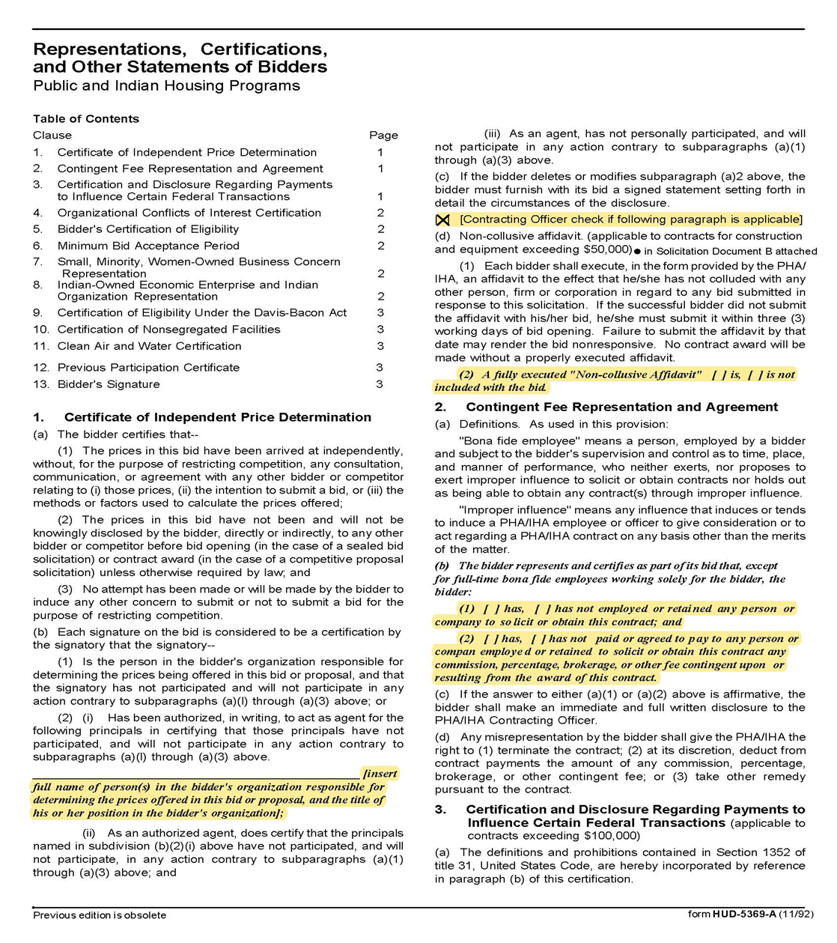

*Article 8 Intentionally Omitted.
CMAR Services for MHA Parkside Housing Redevelopment
Solicitation Document D: HUD Form 5369A - Continued
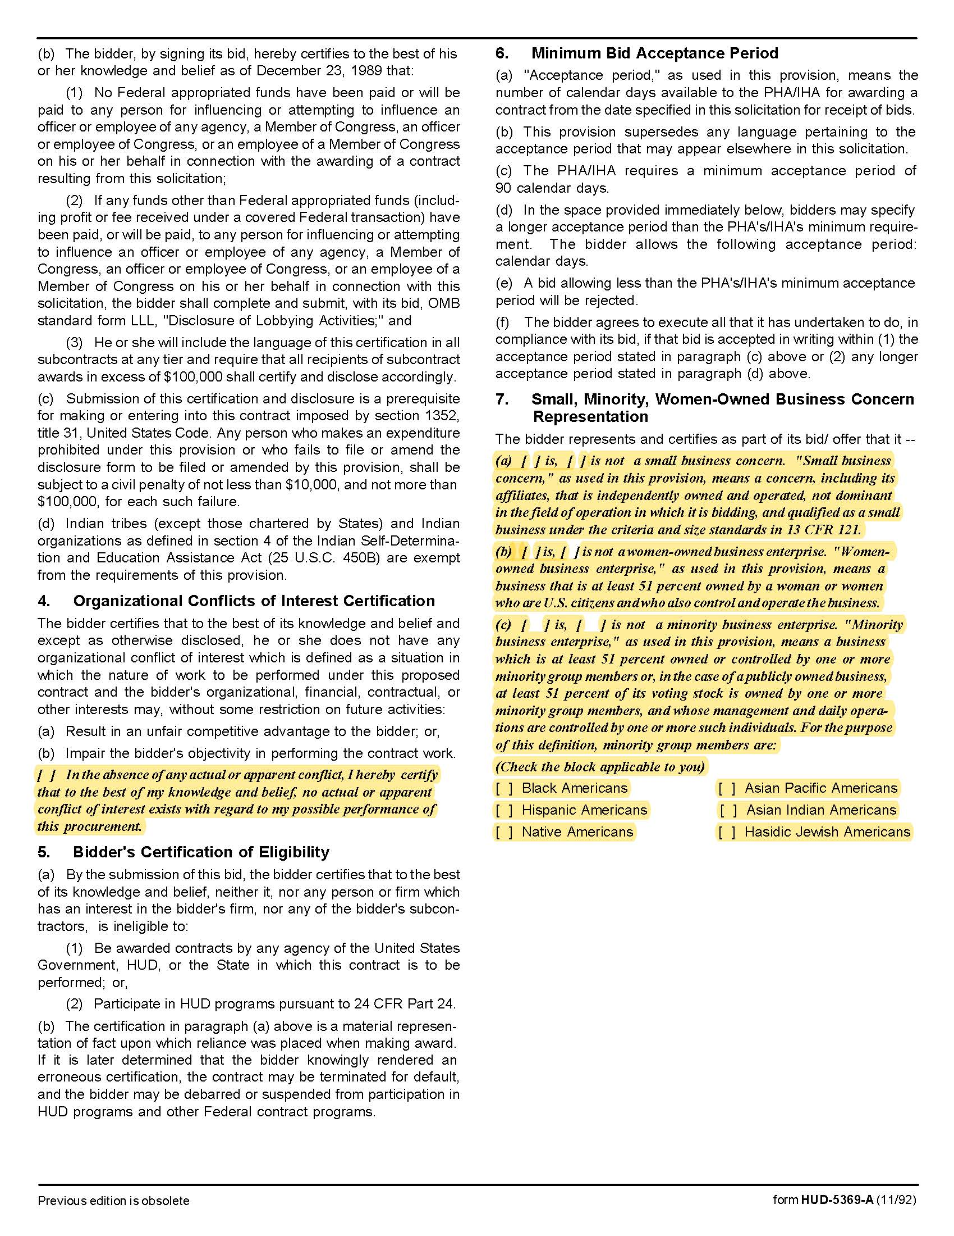

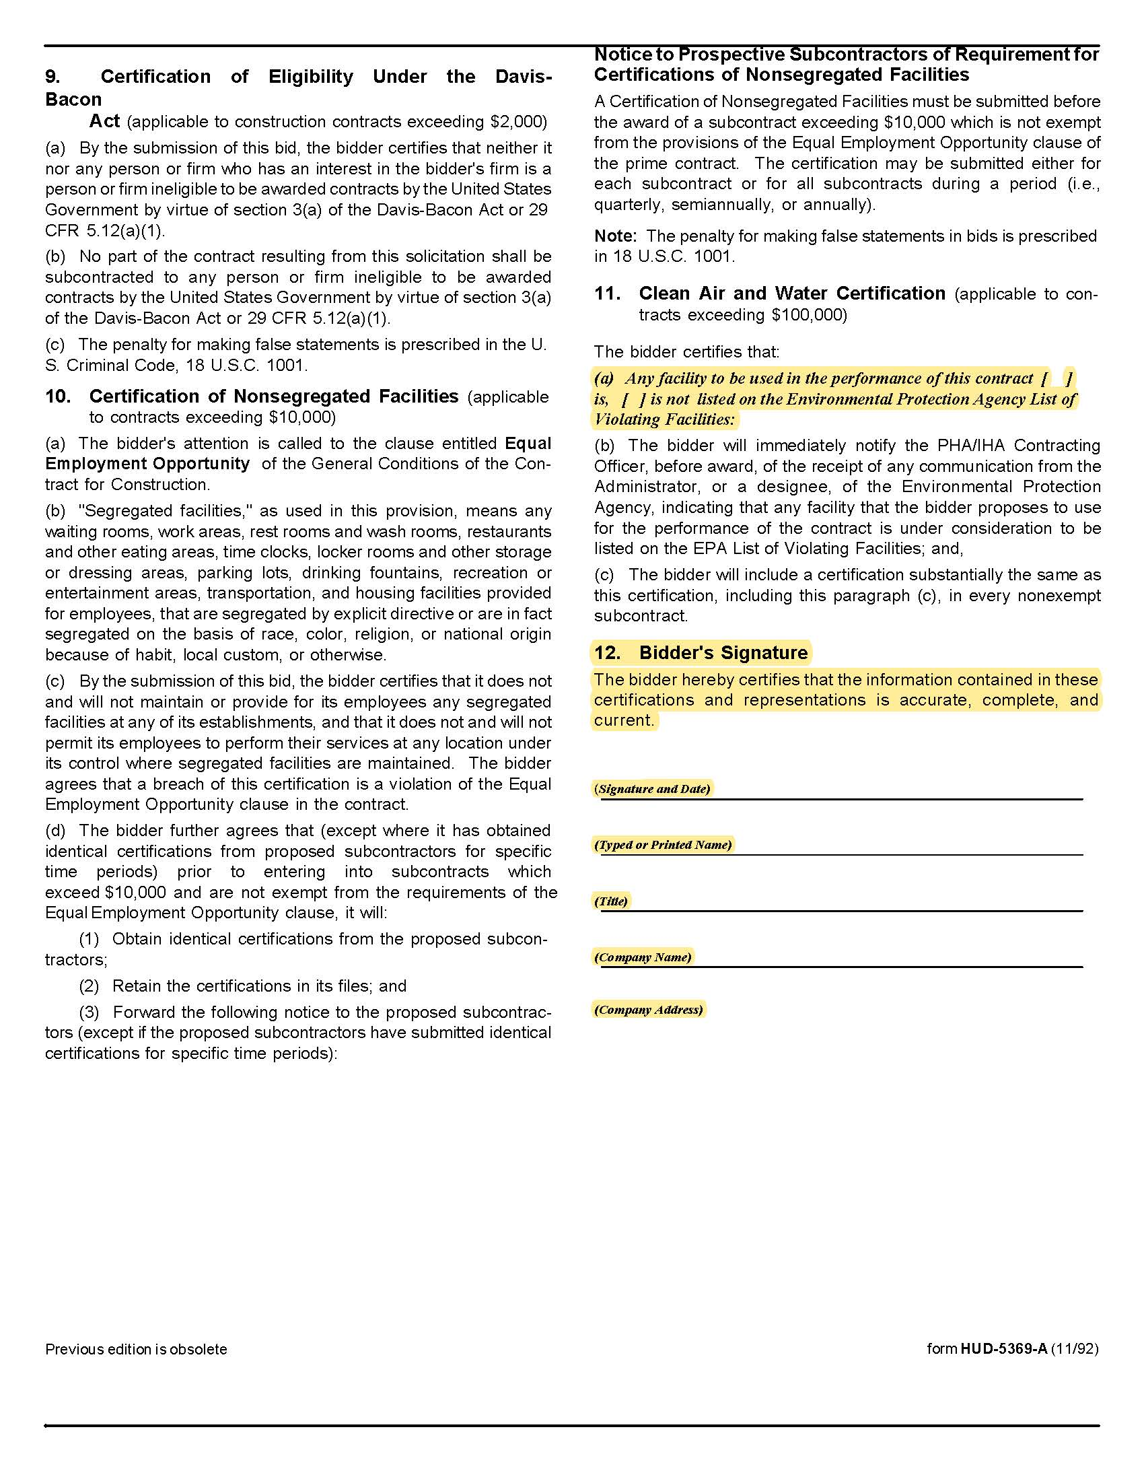
CMAR Services for MHA Parkside Housing Redevelopment
Solicitation Document D: HUD Form 5369A - Continued

CMAR Services for MHA Parkside Housing Redevelopment

Solicitation Document E: Introduction

This is a one-to-two-page introductory letter that:

- Provides a high-level introduction of your company.

- Explains the type of organization (Corporation, Partnership, Joint Venture, LLC, et cetera).

- State of Tennessee CMAR's License Number, Expiration Date, Classification and Limit.

- Details of your company’s history and expertise.

- Details why the project is of interest to you.

- Explains why MHA should select your company.

CMAR Services for MHA Parkside Housing Redevelopment
Solicitation Document F: Construction Manager’s Experience

Use this section to provide:

- Provide a summary of similar projects completed in the last five years. Specifically, highlight and
provide details (project dates, client info, budget/costs, project size, et cetera) for projects that were multifamily residential, a part of a multiphase development, and utilized the construction manager at risk delivery method.

- Please provide three references. References should include clients on one or more of the projects
highlighted in the section above.

CMAR Services for MHA Parkside Housing Redevelopment
Solicitation Document G: Resources

Use this section to provide:

1. Provide an organizational chart showing the proposed structure, interrelationships and interactions of the proposed CMAR team. Describe the proposed roles and estimated involvement for the listed key personnel during pre-construction, construction, and/or throughout the project and include resumes for each. Include similar project experience for each proposed team member.

2. Your current workload (committed projects that are either in construction and pre-construction) and the respective scheduled completion dates for each project.

3. Please describe previous professional experiences or collaboration, if any, with MHM, or Partners’ Development.

CMAR Services for MHA Parkside Housing Redevelopment
Solicitation Document H: Technical Approach

Use this section to provide information that explains your technical approach to the project. Include:

1. A brief description of the organization’s approach to ensuring the successful development of the project. Include how your organization will fit within the Project Team and the anticipated level of involvement from different members of the project team throughout each phase.

2. Identify any components of the Scope of Work included in the RFP (see paragraph18) that the organization is unable to perform or if additional scope should be included but is not currently listed.

3. Your process for assuring the project cost is within the scope and budget and completed on time.

4. Identification of the risks you would anticipate on this type of project and provide the countermeasures you would employ to minimize those risks.

CMAR Services for MHA Parkside Housing Redevelopment
Solicitation Document I: Cost of Services

Using the Service Fee Allocation Chart located in Appendix 1 provide information that explains your Cost of Services and supports your financial strength to provide the necessary bonding capacity. Include:

1. Cost Items Details (do not alter the structure below)

a | Provide the lump sum preconstruction fee. | $
b | Provide a proposed construction management fee including overhead and profit applicable to a project construction budget of approximately $12,000,000. | %
c | State the general conditions cost during construction (on a monthly basis). | $
d | General Liability Insurance Rate | %
e | Builders Risk Rate | %
f | Performance and Payment Bond Rate | %

2. Provide a summary of the organization’s financial capability to ensure a payment and performance bond in an amount equal to 100% of the construction cost limitation noted above.

3. A listing of current and projected bonding capacity within the next 12 months to 24 months.

4. A demonstration of your organization's safety record by providing your Experience Modification
Rating (EMR) and corresponding man-hours of work performed for the past 5 years.

CMAR Services for MHA Parkside Housing Redevelopment

Appendix 1: Service Fee Allocation

 | General Conditions | CM Fee | Preconstruction | Paid By Owner
Personnel Expenses, Including
Superintendent | X
Assistant Superintendent (Indicate if required) | X
Estimator |  | X | X
Project Manager | X |  | X
Project Engineer (Indicate if required) | X
Project Assistants/Office Staff | X
Project Accounting |  | X
Project Executive |  | X | X
Monthly Photos & Reports | X
Scheduling |  | X | X
As-Builts | X
Manuals | X
Prints, Copies, etc. |  |  | X
Mileage | X
Toilets, Temporary Building | X
Cell Phone Service/Internet | X
Equipment: Cameras, Computers, Phone, Print, Copy, Fax | X
Safety Supplies (First Aid, Hard Hats, etc.) | X
Testing (Pre-specified) |  |  |  | X
Mobilization | X
Temporary Utilities |  |  |  | X
Project Signage | X

